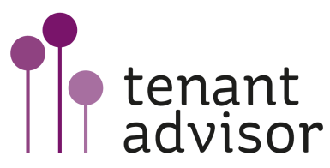

1st Annual Tenant Panel conference
A new age of accountability
Monday 28th November 2011, York Racecourse

Tenant Panels are the Governments preferred route to ensure a new framework of accountability for landlords to ensure their tenants have a real say in how their services are delivered in their local area. This is the Northern Housing Consortium and Scrutiny & Empowerment Partners (SEP) first conference aimed specifically at Tenant Scrutiny Panel members and those involved in supporting them.

We aim to make this an annual event and anticipate it will provide an excellent platform to network and to learn, to support each other, and to promote good practice.

Focusing on the real practical issues the programme will concentrate on:
- Different models and approaches by housing providers
- Effective Tenant Panel development
- Tenant Panels on complaints (the democratic filter)
- Tenant cash-back and the right to manage
- Recruitment, selection and skilling
- Development in government policy around tenant scrutiny and housing
- Understanding landlord performance
- How to challenge housing organisations to ensure scrutiny powers are effective
- Proportionate accountability – getting the balance right
- Working with existing governance structures

The Governments agenda for tenants to play a bigger role in the management of their homes is unfolding through the Department for Communities and Local Government (DCLG) draft directions to the Tenant Services Authority (TSA), the Localism Bill soon to receive Royal Assent, and the new tenants standards, including the tenant involvement and empowerment standard, out for consultation in November by the TSA.
Building on our summer conference on scrutiny, this conference will focus on discussing the details of government proposals and how they affect landlords and tenants.

This conference will look at practical ways for landlords to manage the changes, ways to empower tenants to influence changes to services, and best practice, and provide opportunities for Members of the NHC and SEP to network and share good practice.

So what will I hear at the conference?
- The role residents can play in shaping new ways of working
- Good practice in dealing with complaints and the new role for tenants
- Latest developments on scrutiny
- Best practice and practical outcomes
- Involving young people
- Making best use of social media
- Tenant cash-back
- Right to Manage (RTM) – the options, big and small
- Tools to test the strength of your scrutiny arrangements
- Skills workshops - both technical and as community leaders

By attending this conference you will:
- Hear from policy makers
- Understand the timetable and requirements for change
- Consider the impact of these changes for landlords and tenants, boards and elected members
- Find out who will be doing what, and how – what new arrangements will look like
- Hear good practice identified by sharing some of the early findings from the report on the co-regulatory champions
- Hear examples from pilots and front runners on cash-back and right to manage
- Learn some new techniques and find out how to support each other
- Learn about approaches that deliver empowerment and engagement locally

Speakers include:
- Raphael Runco, Deputy Ombudsman, Housing Ombudsman Service
- TSA & CLG (invited)
- Jessica Crowe, Executive Director, Centre for Public Scrutiny
- Yvonne Davies & Linda Levin, Directors, Scrutiny and Empowerment Partners Ltd
- Tenants and landlords
- Co-regulatory champions
- Scrutiny experts
- Coaching and mentoring experts
- Government

Views expressed at the conference will inform the response that the NHC and SEP will make to any consultation on behalf of its Membership.

Who should attend?
Any tenant or landlord interested in staying ahead of the new agenda; tenants and leaseholders; Directors of Housing & Repairs; Policy, Improvement and Performance Managers; Community and Tenant Involvement Managers

Continuing Professional Development
Delegates will be able to record 4 Continuing Professional Development hours for attending this conference.

Registration: 9.30am; Start: 10.00am; Finish: 4.30pm*

*Please note: whilst we will endeavour to keep to these timings, they may alter slightly when our full programme is finalised.

Delegate Fees:

£99 +vat (All Tenants)
£149 +vat (NHC and SEP Officer Members)
£179 + vat (Non Members)
To book your places at this event please fill in the attached form

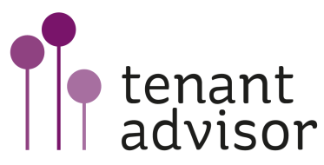

1st Annual Tenant Panel Conference
Monday, 28th November 2011
York Racecourse (Knavesmere Stand)

Contact Name:
Organisation Name:
Organisation Address:

Telephone:
Email:
No. of Places

Delegate Name | Job Title | Email

Special requirements, access, dietary needs or any information relevant to the delegates comfort:

Please return to the events team via fax: 0191 5661001
Or e-mail to: events@northern-consortium.org.uk

